Virtual Machines – An Overview

A Virtual Machine (VM) is a software-based simulation of a physical computer. It allows you to run multiple operating systems on a single physical machine (known as the host), using virtualization technology. Each VM functions like a separate computer with its own CPU, memory, disk space, and operating system. These virtual systems are managed by a hypervisor, a specialized software layer.

# What is Virtualization?

Virtualization is the underlying technology that allows one physical machine to host multiple virtual machines. It abstracts the hardware resources and allocates them to VMs as needed. This process improves efficiency, scalability, and flexibility in both personal and enterprise-level computing environments.

# Types of Virtual Machines

1. System Virtual Machines:  
These emulate complete physical machines, allowing the installation of a full operating system.  
Examples: VirtualBox, VMware, and Microsoft Hyper-V.

2. Process Virtual Machines:  
Designed to run a single program or application. It disappears once the program is terminated.  
Example: Java Virtual Machine (JVM).

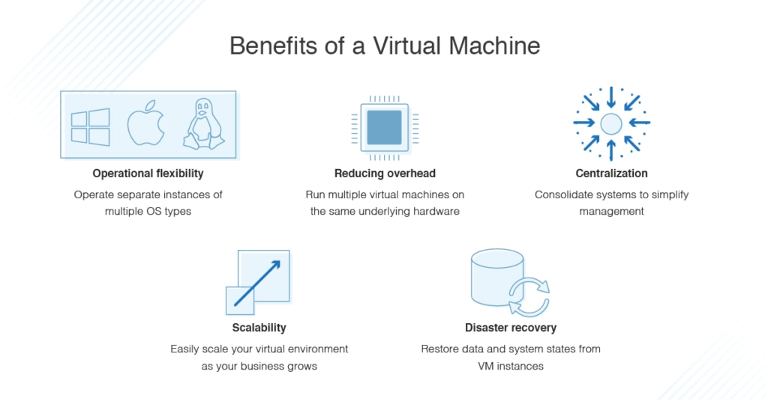

# Hypervisors

A hypervisor is software that creates and manages VMs. It sits between the hardware and virtual machines. There are two main types:

Type 1 (Bare-Metal Hypervisor):  
Runs directly on the physical hardware without a host OS. Used in enterprise environments.  
Examples: VMware ESXi, Microsoft Hyper-V, Xen.

Type 2 (Hosted Hypervisor):  
Runs on top of a host operating system. Easier for personal and development use.  
Examples: Oracle VirtualBox, VMware Workstation.

# Key Components of a Virtual Machine

- Virtual CPU (vCPU): Simulated processor assigned from the host.  
- Virtual Memory: RAM allocated from the host system.  
- Virtual Disk: Acts like a hard drive but is stored as a file on the host.  
- Network Interface: Allows the VM to connect to the internet or internal networks.  
- Guest OS: The operating system installed inside the VM.

# Advantages of Virtual Machines

✅ Isolation: Each VM is independent, reducing risk from crashes or malware.  
✅ Efficient Resource Use: Maximize hardware by running multiple VMs on one system.  
✅ Scalability: Easily create or delete VMs based on demand.  
✅ Portability: VM files can be moved to other systems or cloud platforms.  
✅ Software Testing: Great for testing apps across different OSes.  
✅ Legacy Software Support: Run outdated applications in older OS environments.

# Disadvantages

❌ Performance Overhead: VMs may run slower than native systems.  
❌ High Resource Usage: Running many VMs requires a powerful host system.  
❌ Complexity: Configuration and management require technical knowledge.  
❌ Security Risks: Vulnerabilities in hypervisors can affect all VMs if not patched.

# Real-World Applications

- Cloud Computing: AWS, Azure, and Google Cloud use VMs to provide scalable services.  
- Data Centers: Consolidate physical servers into VMs to reduce cost.  
- Software Development: Test across different environments.  
- Education and Labs: Safe experimentation without harming host systems.

# Conclusion

Virtual Machines are a critical component of modern computing. They offer a secure, scalable, and efficient way to run multiple operating systems and applications on a single hardware platform. VMs provide unmatched flexibility and control in both personal and enterprise environments.

# What is a Virtual Machine (VM)?

A Virtual Machine (VM) allows you to run multiple operating systems simultaneously from the same physical hardware. Traditionally, running Windows and Linux together would require two separate physical machines. Virtualization enables both to run on the same device, which is highly efficient and cost-effective.

Applications are often dependent on specific operating systems, and without virtualization, businesses would need several dedicated systems to run diverse applications. This becomes both space- and cost-intensive due to ongoing maintenance, energy consumption, and repair needs. VMs reduce these burdens by simulating different OS environments on the same machine.

# The Role of a Hypervisor

A hypervisor is the core technology behind virtualization. It acts as the mediator between the host hardware and the virtual machines, isolating and managing them. It simulates hardware resources such as CPU, memory, I/O, and more, creating a self-contained environment for each VM. There are two types of hypervisors: Type 1 (bare-metal) and Type 2 (hosted).

# Containers vs Virtual Machines

Containers are lightweight alternatives to VMs. Unlike VMs, they don’t require a hypervisor or virtual hardware. Containers share the host OS and are ideal for running multiple applications in isolated environments. They are faster and more efficient but are best suited for scenarios where the underlying OS remains the same.

# Challenges in Virtualization and VM Management

While virtualization reduces physical overhead, it increases the complexity of system management. Issues like VM sprawl, storage bottlenecks, and misconfigured dependencies can reduce performance. Effective VM management involves monitoring resource usage, tracking configuration changes, and managing application dependencies.

Using tools like SolarWinds Virtualization Manager (VMAN) can help streamline these processes. It offers real-time alerts, sprawl control, and intuitive dashboards to keep VMs operating efficiently.

# Why Should You Use a Virtual Machine?

- Operate multiple OS environments from one physical system.  
- Reduce hardware, power, and cooling costs.  
- Centralize IT management and improve efficiency.  
- Enable scalability without the need for new physical infrastructure.  
- Facilitate fast and effective disaster recovery through system snapshots and backups.

# Top Hypervisor Vendors

1. VMware vSphere: An industry-leading platform with comprehensive virtualization tools.  
2. Microsoft Hyper-V: Known for ease of use, centralized control, and deep integration with Windows environments.  
3. Others include Citrix XenServer, Oracle VM, and KVM.